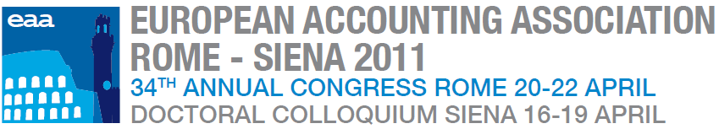

SCIENTIFIC PROGRAM OUTLINE
20 April 2011 AUDITORIUM PARCO DELLA MUSICA, ROME
Welcome address (14:30-15:00)
OPENING SESSION 1 (15:00-16:30)
OPENING SESSION 2 (16:30-18:00)

Opening plenary session
Session | Topic | Invited speakers
Welcome address | Welcoming and initial speech | Massimo Egidi, Luiss Rector  Angelo Riccaboni, Congress Chair, Rector of the University of Siena  Aileen Pierce, EAA President, University College Dublin
Opening session 1 | Coming out of financial crisis: the contribution of, and opportunities for, accounting research | Chair:  Giovanni Fiori, Congress Deputy Chair, Luiss Guido Carli  Speakers:  Carlo Comporti, Acting Secretary General of ESMA  Luigi Gubitosi, CEO of Wind  Irvine Lapsley, University of Edinburgh Business School  Joshua Ronen, Stern School of Business, NYU
Opening session 2 | Managing (within) the academic accounting environment: The sustainability of an international profession | Chair:  Christopher Humphrey, Manchester Business School  Speakers:  Yves Gendron, Université Laval  James Guthrie, Bologna University and Macquarie University  Véronique Malleret, HEC  Martin Messner, University of Innsbruck  Hugh Willmott, Cardiff Business School

21 April 2011 LUISS UNIVERSITY, ROME
Parallel sessions, Symposium 1 (9:00-10:30)
Parallel sessions, Symposium 2 – 3 (11:00 -12:30)
Parallel sessions, Symposium 4 (14:00-15:30)
Parallel sessions, Symposium 5 (16:00-17:30)
Session | Topic | Invited speakers
Symposium 1 – (organized in collaboration with the Journal of Management and Governance) | Accounting and Corporate Governance – The contribution of fieldwork | Chair:  Thomas Ahrens, United Arab Emirates University, Co-editor of the Journal of Management and Governance  Speakers:  Bino Catasús, Stockholm University  Christopher Humphrey, Manchester Business School  Associate Editor of European Accounting Review  Steve Salterio, Queen’s School of Business, Editor-in-chief of Contemporary Accounting Research  Joni Young, University of New Mexico
Symposium 2 –(organized in collaboration with the Journal of Management and Governance) | Managing an Accounting Journal in the ISI Age | Chair:  Roberto Di Pietra, University of Siena, Editor of Journal of Management and Governance  Speakers:  Salvador Carmona, IE Business School, Editor of European Accounting Review  Christopher Chapman, Imperial College London, Editor-in-chief of Accounting Organization and Society  Lisa Evans, University of Stirling, Editor of Accounting in Europe  Robert Scapens, Manchester Business School, Editor of Management Accounting Research
Symposium 3 – (sponsored by KPMG) | Economic and financial crises: impairment and valuation | Chair:  Peter Walton, ESSEC Business School  Speakers:  Orazio Vagnozzi, KPMG  Jerome Haas, Autorité des normes comptables  Executive discussant :  Alessandro Pansa, Finmeccanica
Symposium 4 | Financial Accounting – Research, standard setting and practice: the quest for a missing link? | Chair:  Sasson Bar Yosef, Bocconi University  Speakers:  Mary Barth, Stanford University  Christian Leuz, Chicago Booth University  Laurence van Lent, Tilburg University  Ettore Abate, Partner Ernst & Young
Symposium 5 – (sponsored by ICAEW) | The European Commission green paper on Audit policy: lessons from the crisis and future opportunities | Chair:  Robert Hodgkinson, Executive Director, Technical, ICAEW  Speakers:  Michel Léger, BDO  Giovanni Andrea Toselli - National Technical Partner PwC, Member of Technical Experts Group (TEG) of EFRAG  Marleen Willekens, KU Leuven  Paola Ciani, Consob  Annette Köhler, University of Duisburg-Essen

22 April 2011 LUISS UNIVERSITY, ROME
Parallel sessions, Symposium 6 (9:00-10:30)
Parallel sessions, Symposium 7 (11:00 -12:30)
Parallel sessions, Symposium 8 (14:00-15:30)
Parallel sessions, Symposium 9 (16:00-17:30)
Session | Topic | Invited speakers
Symposium 6 - (organised in collaboration with SISR, Società Italiana di Storia della Ragioneria - Italian Society of Accounting History) | Accounting History – Past, present and future | Chair:  Stefania Servalli, Università di Bergamo, Delegate of the Italian Society of Accounting History  Speakers:  Marcia Annisette, York University, Co-Editor of Critical Perspectives on Accounting  Garry Carnegie, RMIT University, Co-Editor of Accounting History  Christopher Napier, Royal Holloway, University of London, Co-Editor of Accounting Historians Journal  Massimo Sargiacomo, Università di Chieti-Pescara, Editorial Advisory Board of Accounting, Auditing and Accountability Journal  Steve Walker, Cardiff Business School, Editor of Accounting History Review
Symposium 7 – (sponsored by PWC) | Intangibles and Intellectual Capital: The Ultimate Accounting Frontier? | Chair: Stefano Zambon, University of Ferrara  Speakers:  John Dumay, University of Sydney  Thomas Günther, Technische Universität Dresden  Giovanni Andrea Toselli - National Technical Partner PwC, Member of Technical Experts Group (TEG) of EFRAG
Symposium 8 – (organized in collaboration with European Accounting Review) | Familiness in accounting studies: opportunities for research and publications | Chair: Carlo Salvato, Bocconi University  Speakers:  Sasson Bar Yosef, Bocconi University  Gavin Cassar, Wharton Business School, University of Pennsylvania  Luca Gnan, Università di Roma Tor Vergata  Wim Voordeckers, University of Hasselt
Symposium 9 | What is the relevance of management accounting research? | Chair: Robert W Scapens, University of Groningen and Manchester Business School  Speakers:  John Christensen, University of Southern Denmark  Markus Granlund, Turku School of Economics  David Cooper, University of Alberta  Rick Payne, ICAEW

Opening Plenary Session I

Coming out of financial crisis: the contribution of, and opportunities for, accounting research

The past ten years have experienced a massive transformation in the global economic and social environment. The globalization of the market has intensified business relationships, linking ‘distant localities’ in such a way that local happenings are shaped by distant events and, in turn, distant events are shaped by local happenings. The financial crisis that has initially involved only certain industries has been permeating the overall global economy and extending to relevant social and political effects as time goes on. Firms facing this crisis have to provide a rapid response to the changing market conditions by innovating their structures, strategies, and management systems. Moreover, regulators and academics are required to cooperate in order to address the demand for consistent, conceptual frameworks for accounting information and reporting systems.

While the debate on the potential sources of the crisis and on the possible regulatory solutions is vivid and open among regulators, academics and top-managers, less attention has been given to the potential role that accounting (as a discipline) and the academic accounting profession could play in practice in the crisis management, as well as on the impact of the crisis on the discipline of accounting and on the academic accounting profession itself. The following issues deserve further discussion and understandings:
- Does the academic accounting professional have a role to play in the overall crisis management? How can academics help firms to accomplish new regulatory and governance requirements, improve their performance, manage risks, and transform threats in opportunities for change and innovation? How can academics help regulators in finding solutions to the overall crisis management and in defining a common language of accounting?
- How are the relations between academics and regulators, as well as among academics consultants, and business managers evolving (or expected to evolve) in front of the financial crisis?
- What is the contribution of academic research within such an evolving debate?
- Is the crisis any different, in terms of its implications, for the public policy contribution of academic accounting research or is it a debate that remains the same as in previous years?
- What role can accounting academics play and how does that compare to what they are playing now? Who are the main people interested in such research? What impact have they had already? What can an international scholarly community deliver over and above distinct/distanced national communities? What have we learned and forgotten?

The aim of this opening session is to provide a broad discussion on the previous issues, bringing in the perspectives of academics, practitioners, and regulators.

Chair:

Giovanni Fiori, Congress Deputy Chair, Luiss Guido Carli

Speakers:

Joshua Ronen, Stern School of Business, NYU

Irvine Lapsley, University of Edinburgh Business School

Carlo Comporti, Acting Secretary General of ESMA (European Securities and Markets Authority)

Luigi Gubitosi, CEO of Wind

Opening Plenary Session II
Managing (within) the academic accounting environment: The sustainability of an international profession
The global financial crisis has raised many doubts over the functioning of a wide variety of management and regulatory functions and, in the process, generated a host of research questions regarding the nature and efficacy of various accounting, accountability and governance systems. At an intellectual and public policy level, the future should be very bright for the academic accounting profession - but is it?
The world in which accounting academics operate is being substantially challenged and changed by developments in funding and financing systems, the increasing reliance on formal research evaluation/and journal ranking processes and shifts in the supply/demand of students and faculty.
This session is centrally concerned with such shifting working priorities and managerial arrangements – and, ultimately, their impact on the capacity of the academic accounting profession to generate sustainable thought provoking, internationally respected and policy relevant research and teaching programmes.
In exploring the standing and future development of the accounting discipline in the business school and wider university context, the session will consider the nature of academic management processes and their impact on academic values, priorities and achievements. It will review the responsibilities and obligations of senior academic staff, the possibilities for advancement among junior staff, the supply of ‘next generation’ academics - and how the international academic community can best respond to the wide range of opportunities and challenges that it faces.
Key debating points include assessing whether there is a/an:
- growing sense of individualism in academia and a decline in collective, collegial attributes?
- excessive rise in managerialism and centralised target setting/monitoring processes?
- need for the accounting discipline to have a greater capacity to manage its own activities and any associated revenue streams?
- privileging and/or growing marginalisation of certain fields of accounting research
- growing interdisciplinary and public policy relevance to accounting research or an undermining of past disciplinary advancements?
- increasing similarity/diversity in national experiences and contexts?
- a more level playing field in the international accounting research arena or one where there is an evident hierarchy with defined ‘leaders’ and ‘followers’?

Chair:
Christopher Humphrey, Manchester Business School
Speakers:
Yves Gendron, Université Laval
James Guthrie, Bologna University and Macquarie University
Véronique Malleret, HEC
Martin Messner, University of Innsbruck
Hugh Willmott, Cardiff Business School

Symposium 1
Accounting and Corporate Governance: The contribution of fieldwork

Corporate governance research is often criticised for its lack of field research. Very little is still known about the functioning of corporate governance systems in practice. There is, however, an emerging body of field research in accounting and auditing that has begun to address some key corporate governance issues. These include, for example, the uses of information by boards of directors, the functioning of corporate governance committees, strategic planning and strategising, the flow of information between corporations, capital markets, and regulators, the hybridising of diverse bodies of expertise around corporate governance, and the drafting and uses of accounting and audit standards. Working in different areas of accounting, the symposium’s panellists have been contributing to this research in the interstices of accounting and corporate governance and will be discussing its future.
Chair:
Thomas Ahrens, United Arab Emirates University, Co-editor of the Journal of Management and Governance

Speakers:
Bino Catasús, Stockholm University
Christopher Humphrey, Manchester Business School, Associate Editor of European Accounting Review

Steve Salterio, Queen’s School of Business, Editor-in-chief of Contemporary Accounting Research
Joni Young, University of New Mexico
This symposium was organized in collaboration with the  Journal of Management and Governance | 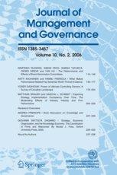

Symposium 2 – Editors’ Panel

Managing an Accounting Journal in the ISI Age
Evaluating the quality of the published research is not a simple task. Notwithstanding the important that issue implies and the fact that all the scholars recognize the importance of this need, the adoption of the SSCI continue to be under discussion. All the Journal activities are deeply influenced (and in some ways “distorted”) by the existence of the ISI system. The reviewers selection, their activity, the value of their activity, the decision to launch Special issues, the need to detect bad behaviour from authors, etc. are strongly influenced by the existence of the ISI system. And this is true if a Journal belongs to the club or is trying to be admitted as a new member. This symposium aims to discuss this topics avoiding the traditional way to present the characteristics of the invited accounting Journal and the policies followed by their respective Editors.
Chair:
Roberto Di Pietra, University of Siena, Editor of Journal of Management and Governance
Speakers:
Salvador Carmona, IE Business School, Editor of European Accounting Review

Christopher Chapman, Imperial College London, Editor-in-chief of Accounting Organization and Society

Lisa Evans, University of Stirling, Editor of Accounting in Europe

Robert Scapens, Manchester Business School, Editor of Management Accounting Research

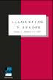 | 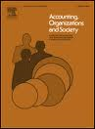 | 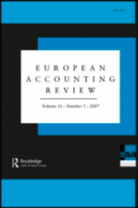 | 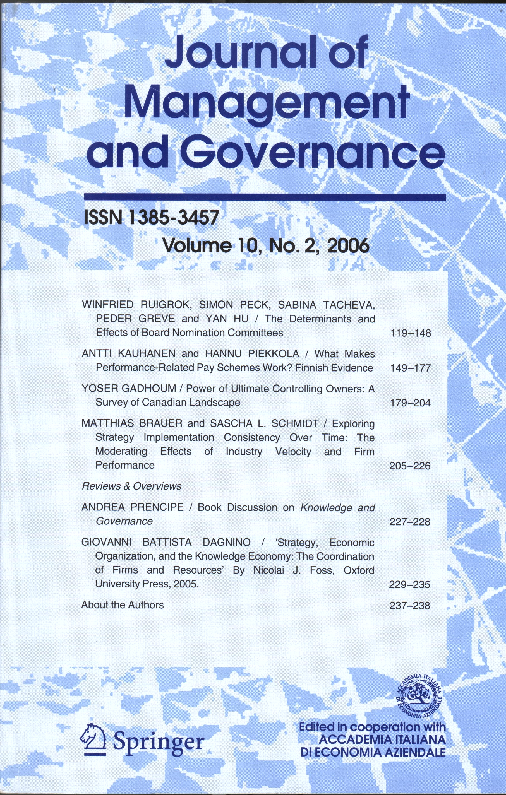 | 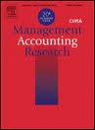

KPMG Symposium 3

Economic and financial crises: impairment and valuation
The IASB’s impairment models, IAS 36 and IAS 39, both use current market data, but during the financial crisis the markets have been more than usually volatile, making valuation and impairment judgments more difficult for the issuer, auditor and user.
The treatment of uncertainty in fair value measurements becomes critical when the observable markets don’t express the best estimate of likely future cash flows. The fair value hierarchy that is included in the upcoming IFRS on fair value should provide increased disclosure on uncertain measurements and reduces information asymmetries, but the reaction of the users is largely unexplained.
The IASB is in the process of changing impairment rules for financial instruments, but does it also need to address the impairment of intangibles generally and goodwill?

Chair:
Peter Walton, ESSEC Business School

Speakers:
Orazio Vagnozzi, KPMG

Jerome Haas, Autorité des normes comptables

Executive discussant :
Alessandro Pansa, Finmeccanica

Symposium 4

Financial Accounting – Research, standard setting and practice: the quest for a missing link?
Academics are often facing the question of the relevancy of their research. Such a question is directed to most of the academic fields, and also to accounting academics. This question is often raised by professionals, sometimes with added sarcasm, pointing to the fact that accounting research issues are lagging rather than leading, and difficult to be applied in practice, especially with reference to archival/empirical or theoretical studies. A classical question put to accounting researchers is of the sort “you produce a large volume of papers, go through the trouble of publishing it… and… who is going to use it? What is the value of your products?” Some cynically suggest that we engage in research only to obtain tenure/promotion.

As accounting academics, we need to address such issues and respond to questions such as: Research must be relevant to whom? Who are the potential users of academic research? Can the ‘results’ from accounting research be applied?
In this symposium we gathered an excellent panel to address these questions, representing the academic, the standard setter and the practitioner sides.
The panel will actively interact with the audience through questions and answers.

Chair:
Sasson Bar Yosef, Bocconi University

Speakers:

Mary Barth, Stanford University

Christian Leuz, Chicago Booth University

Laurence van Lent, Tilburg University

Ettore Abate, Partner Ernst & Young
ICAEW Symposium 5

The European Commission green paper on Audit policy: lessons from the crisis and future opportunities
The EC is keen to pursue change in the aftermath of the financial crisis. At an EC conference on financial reporting and auditing issues, held in Brussels in February, Commissioner Michel Barnier stated ‘The status quo is not an option for the auditing world. It's not about changing for the sake of change, but to reply to very real needs which we can no longer ignore.’ He noted that proposals for a Directive will be published in November 2011 at the latest and did not rule out any of the ideas under consideration. The key areas he addressed in his speech were:
- Clarifying the role of auditors
- Strengthening the independence of the profession
- Promoting an evolution in the structure of the audit market
- Facilitating SME growth
- Reinforcing international cooperation
This symposium will consider practical measures to achieve these policy objectives and the contribution of the academic community.

Chair:
Robert Hodgkinson, Executive Director, Technical, ICAEW

Speakers:
Michel Léger, BDO

Giovanni Andrea Toselli - National Technical Partner PwC, Member of Technical Experts Group (TEG) of EFRAG

Marleen Willekens, KU Leuven

Paola Ciani, Consob

Annette Köhler, University of Duisburg-Essen

Symposium 6
Accounting History: Past, Present and Future
Since 70s, when accounting history emerged as field of research, this area has showed a growing interest within the accounting debate. The aim of the symposium is to outline the state of art of accounting history, after forty years of development. This long path has made emerge active communities of Scholars, national/international Academies deeply involved in the debate and specialist Journals. The role, the contribute and the future of this specific field to the accounting debate will be explored by editors and delegates of generalist accounting journals and specialist accounting history journals. In particular, the Symposium intends to outline:
- Past and present of accounting history by statistics on publications, main research topics, alternative theoretical approaches and research methodologies, role of accounting history academies, etc.
- Future research agenda and special issues.

Chair:
Stefania Servalli, Università di Bergamo, Delegate of the Italian Society of Accounting History

Speakers:
Marcia Annisette, York University, Co-Editor of Critical Perspectives on Accounting
Garry Carnegie, RMIT University, Co-Editor of Accounting History
Christopher Napier, Royal Holloway, University of London, Co-Editor of Accounting Historians Journal
Massimo Sargiacomo, Università di Chieti-Pescara, Editorial Advisory Board of Accounting, Auditing and Accountability Journal
Steve Walker, Cardiff Business School, Editor of Accounting History Review

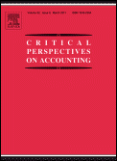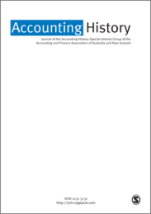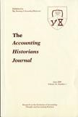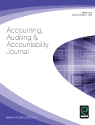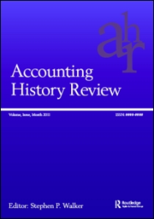

This symposium was organized in collaboration with SISR (Società Italiana di Storia della Ragioneria – Italian Society of Accounting History)

PWC Symposium 7

Intangibles and Intellectual Capital: The Ultimate Accounting Frontier?

Over the past 15 years the academic and professional debate on how to report on and visualise intangibles has been unfolding. Throughout these years, scholarly research has taken many different directions, trying – inter alia – to find a better way to account for intangibles on the balance sheet, exploring new models and methodologies for valuing, managing and analysing intellectual capital, or advocating the development of non-financial information and narratives to represent how intangibles add value to organizations. Thus, the research on intangibles has being growing with a surprising vitality and endurance.
The Symposium aims to revisit and rejuvenate the debate on intangibles and intellectual capital in the light of most recent international developments. In particular, some of the latest trends and issues in the research and practice of this field will be addressed and discussed.
Topics which will be dealt with are:
- Critical perspectives on intellectual capital literature;
- Company disclosure on intangibles;
- The conceptual inconsistencies of impairment tests in theory, practice and regulations; and
- The policy dimension in the intangibles arena and role of academics therein.

Chair:
Stefano Zambon, University of Ferrara

Speakers:
John Dumay, University of Sydney

Thomas Günther, Technische Universität Dresden

Giovanni Andrea Toselli - National Technical Partner PwC, Member of Technical Experts Group (TEG) of EFRAG

Symposium 8
Familiness in accounting studies: opportunities for research and publications
The main aim of this symposium is to attract the attention of accounting scholars to Family Firms as a fertile empirical field for insightful research and academic publications. Accounting practices in family firms, although displaying evident unique features, have received relatively little attention as distinct from their equivalents in publicly held firms. This may have hampered conceptual advancements in both accounting and family business literatures. This symposium will assess accounting areas in which the “family entity” plays a distinct role, and elaborate on important characteristics of these phenomena. The symposium will emphasize the fact that additional research efforts may illuminate both unresolved issues in the accounting literature, and so far neglected dimensions of the family business entity, hence contributing to both literatures. Finally, the symposium will illustrate several different avenues for research at the accounting/family-business interface, providing practical guidance on how to successfully address interesting topics and open research questions. The symposium will feature some of the most active scholars in this area, and the Editors of three recent Special Issues of international academic journals focused on accounting in family firms.
Chair:
Carlo Salvato, Bocconi University
Speakers:
Sasson Bar Yosef, Bocconi University
Gavin Cassar, Wharton Business School, University of Pennsylvania
Luca Gnan, Università di Roma, Tor Vergata
Wim Voordeckers, University of Hasselt
This symposium was organized in collaboration with European Accounting Review – special section on “Accounting and reporting in family firms”

Symposium 9
What is the relevance of management accounting research?
In recent years politicians and public administrators have started to ask questions about the relevance of University research. How does it contribute to the society which funds much of it? In the field of accounting, the relevance of interpretive management accounting research was questioned in the polyphonic debate which was published in Critical Perspectives in Accounting in 2008. Similar questions could be asked about management accounting research more generally. The writings of gurus and other major figures have had a significant impact on practice in recent years, with a whole range of new management (accounting) techniques. What impact has the work of other management accounting researchers had on practice?
This question, however, presupposes that management accounting research could or should have an impact on practice. Researchers who adopt a managerialist approach would probably argue that their research should and does have an impact on management accounting practice, in the form of new management techniques and/or “better” applications of existing techniques. Such research could be further developed through more interventionist field research. But what about the relevance of mathematical modelling and other quantitative research methods, such as agency theory, contingency theory, and quantitative empirical research more generally? Quantitative management accounting researchers could point to the corpus of knowledge about the drivers of management accounting practices which has been developed over the last 30/40 years – but has this research had impact on practice? Then there is critical management accounting research. Critical accounting researchers would probably have quite different views about the relevance of management accounting research and how we might assess its contribution to society. Critical researchers might point to the importance of critical research in public debates about the way accounting privileges certain groups in society and disadvantages others.
This symposium will explore what it means to talk about the “relevance” of management accounting research, examine its relevance/contribution to society, and discuss whether and how its relevance/contribution might be enhanced in the future.

Chair:
Robert W Scapens, University of Groningen and Manchester Business School
Speakers:
John Christensen, University of Southern Denmark
Markus Granlund, Turku School of Economics
David Cooper, University of Alberta
Rick Payne, ICAEW

